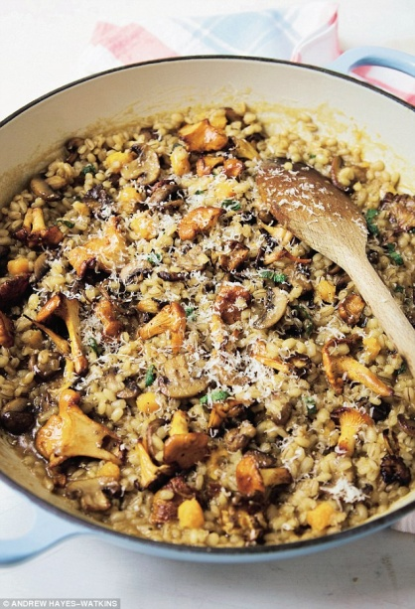
Barley Risotto with Mushroom & Butternut Squash

SERVES 4
- 1 tbsp olive oil
- 50g butter
- 1 onion, finely chopped
- 1 garlic clove, finely chopped
- 400g mixed mushrooms, wiped clean and finely sliced
- 200g butternut squash, peeled and diced
- 250g pearl barley (or spelt)
- ½ tsp dried sage or 1 tbsp chopped fresh sage
- 1 litre chicken or vegetable stock
- 25g Parmesan cheese, grated, plus extra Parmesan to serve
- salt and black pepper

- Heat the olive oil and half the butter in a large saucepan. Gently fry the onion and garlic for 2 minutes, then add the mushrooms and butternut squash.
- Continue to cook for about 5 minutes until the mushrooms are collapsing down and everything is softening.
- Add the barley or spelt, then the sage and season with salt and pepper. Stir well
- Pour in the stock and bring it to the boil. Turn down the heat and simmer gently, stirring regularly, until most of the liquid has been absorbed and the barley is tender
- Beat in the rest of the butter with the Parmesan until the risotto is creamy.
- Serve with more grated Parmesan.

