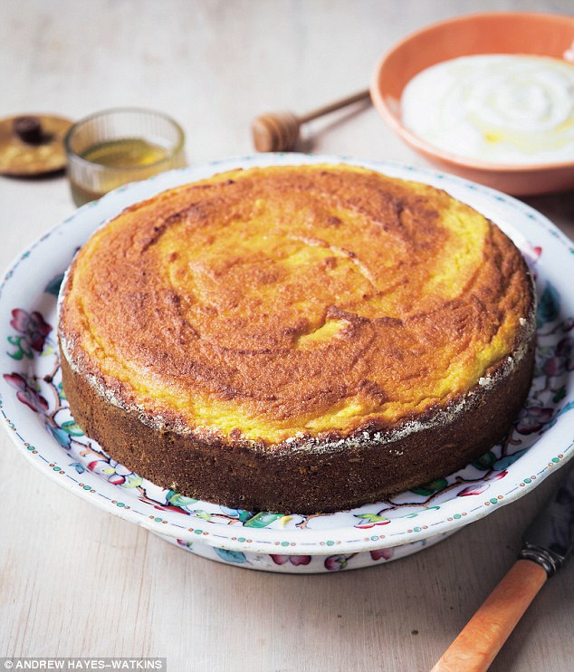
Orange & Almond Cake
Serves 10
- 2 medium Oranges
- Butter for greasing
- Flour for dusting
- 6 eggs
- 200g honey
- 350g ground almonds
- 1tsp baking powder

- Put the whole oranges in a saucepan cover with water, bring to boil and add a lid, simmer for 1- 1 1/2 hours until soft (you should be able to pierce skin with handle of a wooden spoon)
- Drain oranges set them aside to cool – (leave overnight if possible)
- When ready to make cake- (or when oranges are completely cold)cut in half and remove pips it any, place in a food processor and blitz
- Preheat oven to 180/160fan/gas 4,
- grease 24cm round cake tin – loose bottomed would be preferable, with butter and then flour
- Whisk eggs in a bowl until they are frothy
- Add honey ground almonds baking powder then orange mix
- Mix thoroughly but lightly,
- Our into cake tin
- Bake for 45-50mins until firm to touch and shrinking from sides of tin
- Leave to cool in tine before turning out
- Serve with yoghurt or crème fraîche

