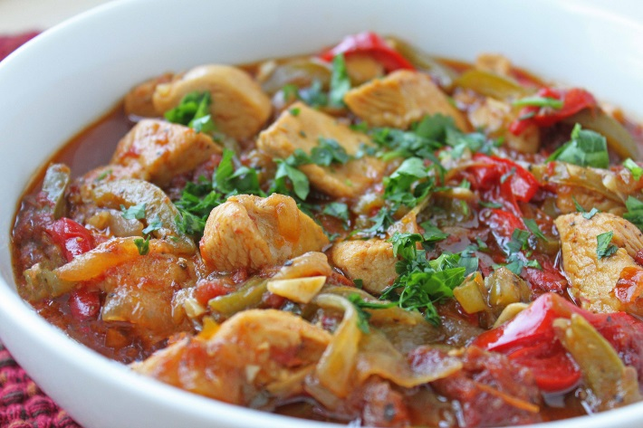
Chicken with Aubergine and Peppers
Serves 2
- Tbsp. coconut/Olive oil
- 2 chicken breasts fillets, sliced into strips
- 2 garlic cloves crushed
- 2tsp ground cumin
- 2 large red onions diced
- 1 red pepper diced
- ½ medium aubergine diced
- 1 chicken stock cube
- 200g tomato passata

- Heat oil in a frying pan to sear the chicken strips
- Remove from pan and set aside
- Add garlic and cumin to pan and fry for 30 seconds
- Add onions and pepper and cook for 1 min
- Add the aubergine and fry gently for 5 mins or until all veg has softened
- Return to pan and crumble the stock cube over mix
- Add passata and simmer for 10-15mins until meat is cooked through
- Serve on wholemeal pasta of choice or Jacket potato
- Season with balck pepper and torn basil (no need for salt due to stock cube)

