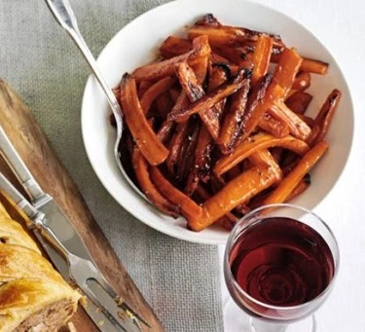
Side
Roasted carrots (V)
Serves 8, Kcals 158, Fibre 6g
- 2kg carrots, halved or quartered lengthways
- 4 tbsp olive oil
- 4 tbsp honey
- 2 tbsp red wine or cider vinegar

- Heat the oven to 200C/180C fan/gas 6.
- Bring a large pan of water to the boil. Add the carrots, bring back up to the boil and cook for 5 Drain and leave in a colander to steam-dry for a few minutes, and then toss in a large roasting tin with the olive oil, honey, vinegar and seasoning.
- Roast for 30-40 mins.

