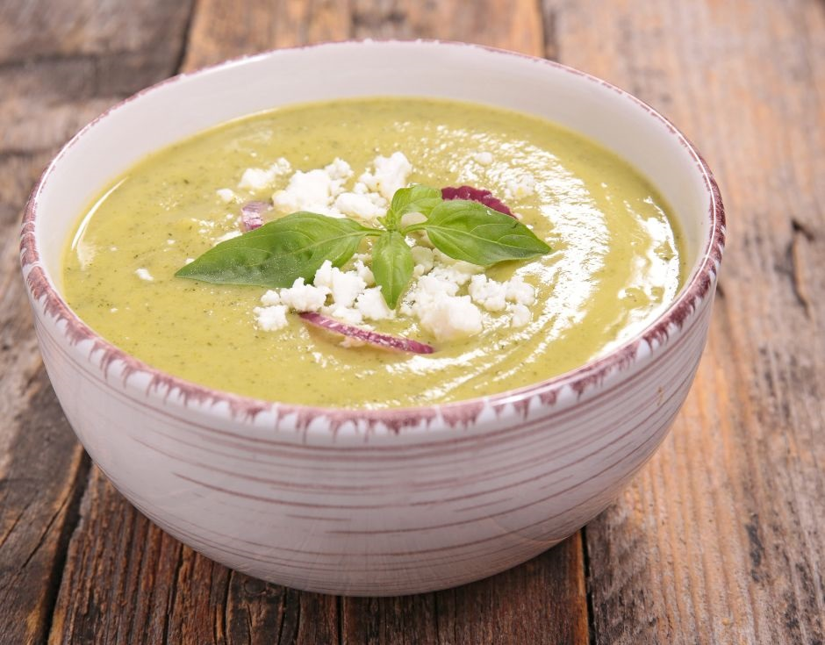
Courgette and Basil Soup (V)
Serves 4
- 500g courgette cut into chunks
- 1 tablespoon olive oil
- 200ml cup water
- 1 vegetable stock cube
- 10g parmesan
- 1 tablespoon milk
- Large handful (25g) baby spinach
- ½ bunch fresh basil

- Preheat the oven to 160°C. Roast the courgette for 15 minutes
- Add the olive oil and courgette to a large saucepan. Add water and stock cube. Simmer over a medium-high heat for 10 minutes until the courgette is tender
- Add parmesan, milk, spinach, basil and pepper
- Blend well until there are no lumps. Add more water as required to the desired consistency
- Serve hot with fresh basil leaves and a drizzle of olive oil

