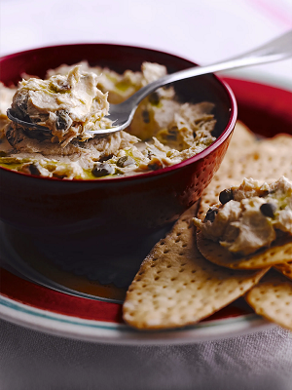
Tuna & caper butter
Serves 4, Kcals 110, Fibre 0g
- 2 anchovies, from sustainable sources
- 1 tablespoon capers
- 2 x 185g tins of tuna in olive oil
- 210g butter

- Chop the anchovies, and drain the capers and tuna.
- Blend in a food processor with the butter until smooth.
- Serve with Italian flatbreads or crispbread.

