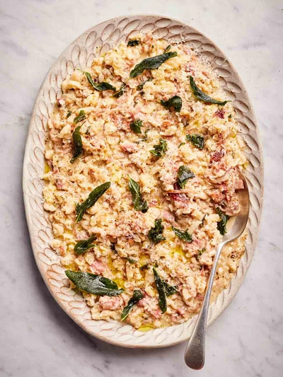
Teardrop Gnocchetti
serves 4, Kcals 638 fibre 3.1g
- 100g ham or ham hock
- Splash of olive oil
- 400g plain flour
- 3 large free-range eggs
- 300ml semi-skimmed milk
- 1 whole nutmeg, for grating
- 12 fresh sage leaves
- 3 sprigs of fresh oregano
- ½ a large onion
- 250ml stock, make using ham or chicken cube
- 60g Parmesan cheese

- Shred the ham hock,
- Pile the flour into a large bowl, crack in the eggs, pour in the milk, add a pinch of sea salt and a few gratings of nutmeg, then whisk together to make a thick batter.
- Bring a large pot of salted water to the boil.
- heat olive oil in a large non-stick frying pan over a medium-low heat. Strip in the sage and oregano leaves and fry for 30 seconds, or until crisp, then remove to kitchen paper.
- To make the sauce,
- finely chop the onion and place in the frying pan with a with a little olive oil. Cook gently until onion is translucent.
- Add the the shredded ham. Pour in stock and bring to the boil.
- Working quickly, pour the batter into a colander over the pan of boiling water and use a spoon to swirl and push it around, encouraging it to fall through the holes of the colander, straight into the water. Cook for just 2 or 3 minutes, or until they float to the surface, then use a slotted spoon to transfer straight into the sauce. Off the heat, grate over most of the Parmesan, stirring to coat.
- Transfer the Gnocchetti into a serving platter, grate over the remaining Parmesan and top with the crispy herb leaves, grating over a little extra nutmeg, to serve.

https://www.jamieoliver.com/recipes/pork/teardrop-gnocchetti

