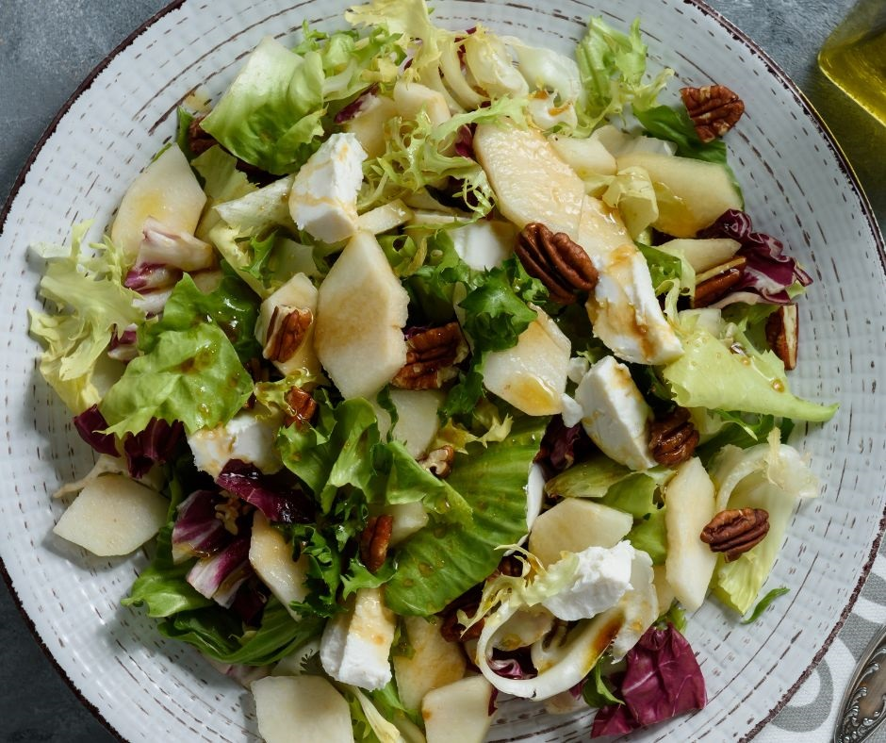
Pear and goat's cheese salad (V)
Serves 6 as a starter. Kcals 166, Fibre 2.9g
- 1 red onion, thinly sliced​
- ½ lemon, juiced​
- 3 ripe seasonal pears
- 80g pack watercress, spinach & rocket
- 1 rosemary sprig, leaves picked and roughly chopped
- 125g pack soft goat’s cheese
- 2 tbsp toasted flaked almonds
- For the cranberry vinaigrette
- 2 tsp red wine vinegar
- 1 tbsp extra-virgin olive oil
- 1 tbsp cranberry sauce
- ¼ tsp Dijon mustard

- Put the onion in a heatproof bowl and cover with boiling water; set aside for 5 mins, then drain.
- Meanwhile, put the lemon juice in a mixing bowl and half-fill with cold water. Core the pears, slice each into 6 wedges, then
- transfer to the lemon-water.
- Put all the vinaigrette ingredients in a jug and use a hand blender to blitz smooth; season to taste. Add 1-2 tsp water as needed to loosen.
- Toss together the salad leaves, onion, half the rosemary and 2 tbsp cranberry vinaigrette. Transfer to a serving platter, top with the pears, then crumble over the goat’s cheese and scatter with the almonds and remaining rosemary. Drizzle with the remaining dressing to serve.

Tip
Thyme or parsley will work just as well as rosemary; you can also swap the flaked almonds for pecans, or toasted sunflower or pumpkin seeds.

