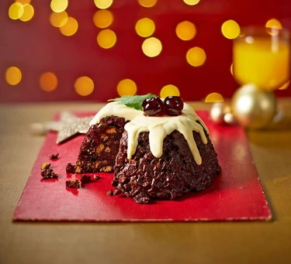
Dessert
Christmas chocolate & cranberry fridge cake (V)
Serves 8 – 10, Kcals 508, Fibre 5g
Feel free to add other bits to this Christmas pudding fridge cake, such as nuts or shop-bought chocolates. You could add a splash of your favourite tipple, too
- 1tsp sunflower oil, for the pudding basin
- 300g dark chocolate, chopped into small pieces
- 100g butter, at room temperature
- 100g golden syrup
- 200g ginger nuts or spiced Christmas biscuits
- 150g dried cranberries
- 200g glacé cherries
- pinch of sea salt flakes
- 50g white chocolate, chopped (optional)
- 2 fresh bay leaves (optional)

- Use the sunflower oil to oil a 1.2-litre pudding basin.
- Tip the dark chocolate, butter and syrup into a heatproof bowl, then put the kettle on to boil.
- Pour the hot water into a slightly smaller heatproof bowl and sit the bowl of chocolate over it, stirring occasionally until melted.
- Meanwhile, put the biscuits in a food bag and use a rolling pin to crush them into smaller pieces.
- Tip the crushed biscuits, the cranberries and most of the cherries (reserve two for decorating later) into the melted chocolate along with the sea salt flakes.
- Mix together using a rubber spatula until thick and combined, then scrape into the prepared basin, pushing it down so it’s packed in and comes up the sides.
- Chill for at least 3 hrs or ideally overnight until the fridge cake is completely set and firm.
- Put the kettle on to boil again, then fill a large heatproof bowl with the hot water.
- Carefully dip the basin into the water until the cake can just be loosened from the sides using a palette or cutlery knife.
- Invert the cake onto a serving plate and chill to set the sides again. If you like, melt the white chocolate over a bowl of hot water as before, then spoon it over the pudding to create a dripping cream effect.
- Chill again until set, then decorate with the two reserved cherries and the bay leaves.

