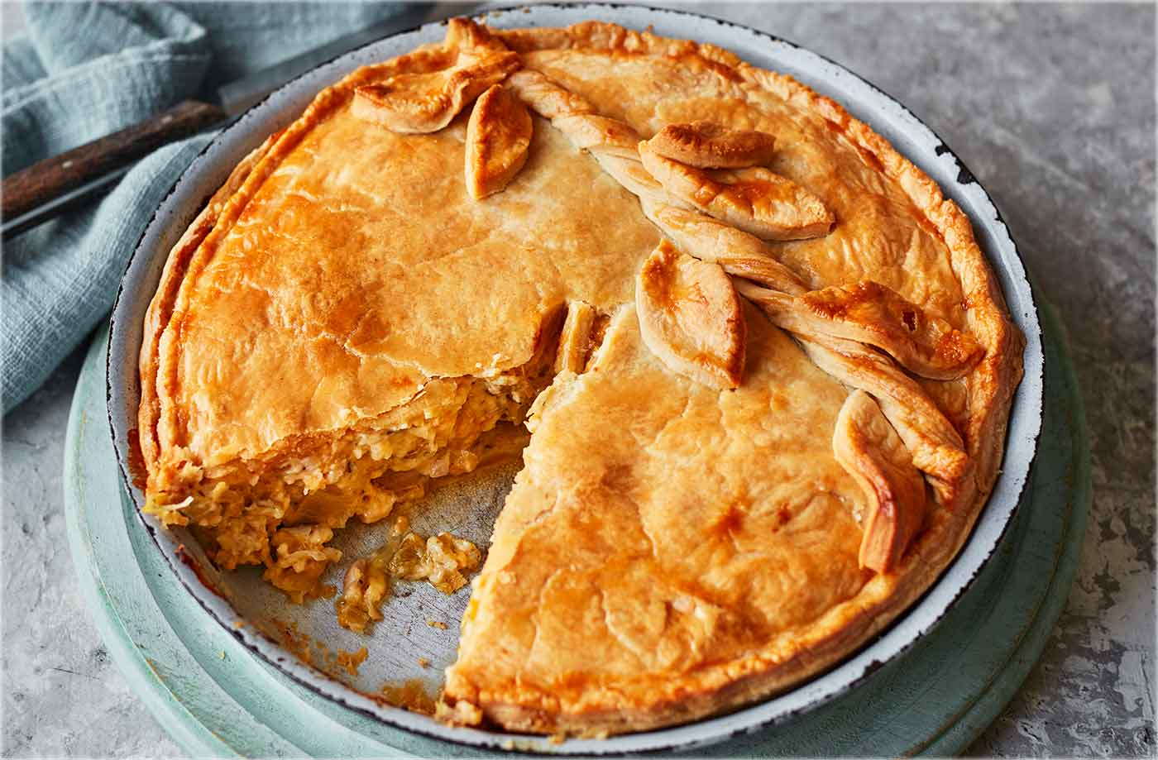
Ultimate cheese and onion pie (V)
Serves 8, Kcals 391, Fibre 1.3g

- 200g plain flour, plus extra for dusting
- 100g chilled butter, cubed
- 1 tbsp olive oil
- 1 red onion, finely chopped
- 4 spring onions, trimmed and finely chopped
- 2 leeks, trimmed and finely chopped
- 4 thyme sprigs, leaves stripped
- 175g Cheddar, grated
- 175g Cheshire cheese, grated
- 1 egg, lightly beaten
- baby leaf salad, to serve

- Combine the flour and a pinch of salt in a large bowl. Work the butter into the flour with your fingertips until the texture resembles coarse breadcrumbs. Gradually add 3-4 tsp ice-cold water, mixing until it just comes together (you may need a little less or more liquid, but don’t add too much). Bring the pastry together with your hands and shape into a disc. Wrap in clingfilm and
- Preheat the oven to gas 5, 190°C, fan 170°C and put a baking sheet on the middle shelf. Heat the oil in a large, heavy-based pan over a low heat. Add the red onion, season and cook for 1 min. Add the spring onions, leeks and thyme, stir well and cook for 2-3 mins. Add 200ml water and cook for 6-8 mins, stirring occasionally, until the liquid has almost evaporated and the onions are soft.
- Remove the pan from the heat and use a slotted spoon to transfer the mixture to a large bowl, discarding any liquid in the pan. Leave to cool completely. Once cooled, gently stir through the cheeses and half the beaten egg. Set aside.
- Remove the pastry from the fridge. Cut off a third, rewrap in clingfilm and return it to the fridge. On a lightly dusted surface, roll out the remaining two-thirds so it’s large enough to fill a 20cm-round, 4cm-deep loose-bottomed tin.
- Using a rolling pin to help you, drape the pastry into the tin, allowing the edges to overhang. Gently press the pastry into the sides of the tin so it fits snugly. Roll out the remaining third of the pastry for the lid.
- Spoon in the filling and spread it evenly over the pastry case. Use a little water to wet the rim of the pie and cover with the pastry lid. Press around the edge to seal; trim any overhanging pastry. Roll out the pastry trimmings, cut out leaves and twist a length into a stalk for decoration.
- Brush the top of the pie with most of the remaining egg, then make 2 small slashes in the top with a knife to let steam escape. Arrange the leaves and stalk on top, then brush with egg. Place on the hot baking sheet in the oven and bake for 40-50 mins until golden. Remove from the oven and leave to cool for 20 mins, then remove from the tin and serve with the salad.

Tip
No time to make pastry? Use a 375g pack of shortcrust and continue from step 2.

