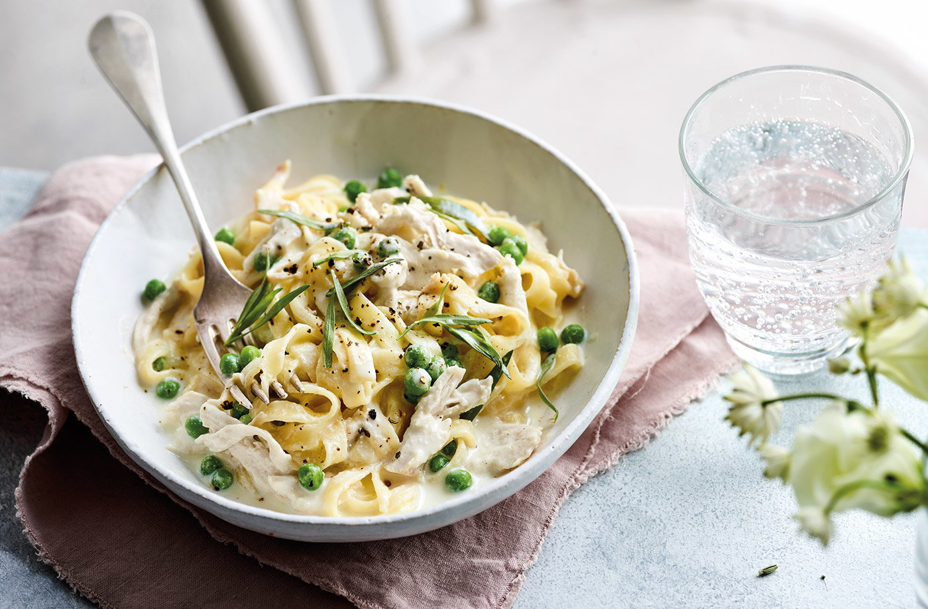
Milk-poached chicken with peas and pasta
Serves 4, kcals 462, Fibre 5.4g
- 2 chicken breasts
- 500ml whole milk
- 2 garlic cloves, sliced
- 1 lemon, zested
- 6 tarragon sprigs
- 225g tagliatelle
- 175g frozen peas
- 3 tbsp cornflour
- 80g reduced-fat soured cream
- 1 tbsp Dijon mustard
- Place the chicken breasts between 2 sheets of clingfilm on a chopping board. Bash the chicken with a rolling pin to flatten to about 1.5cm thick.
- Pour the milk into a medium saucepan and add the chicken, garlic, lemon zest and half the tarragon. Season, bring to a gentle simmer over a low heat and cook for 10 mins or until the chicken is cooked through. Remove the chicken and set aside to rest for 10 mins before cutting or shredding into thin slices.
- Meanwhile, bring a large pan of salted water to the boil and cook the tagliatelle for 10 mins until tender, adding the peas for the final 2 mins.
- Mix the cornflour with 4 tbsp cold water to make a paste. Strain the chicken poaching liquid into a clean saucepan and add the cornflour paste, soured cream and mustard. Stir together and simmer gently over a low heat for 2-3 mins until thickened.
- Drain the pasta and peas. Add to the creamy sauce along with the chicken and toss gently to combine. Divide between 4 plates or bowls and scatter with the remaining tarragon to serve.

Tip: Gently simmering the chicken in the milk, and when thickening the sauce, will ensure the mixture doesn’t split – the liquid should just have a few small bubbles coming to the surface rather than a strong, bubbling boil.

