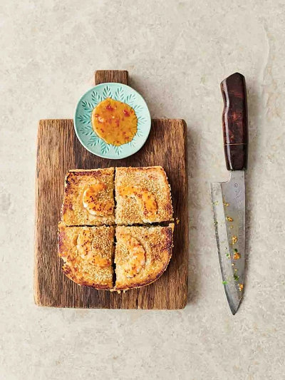
Prawn toast toastie
serves 2, Kcals Fibre
- 2 spring onions
- 160g raw peeled king prawns, from sustainable sources
- 2cm piece of ginger
- ½ tablespoon low-salt soy sauce
- 1 large free-range egg
- 4 slices of white bread
- 2 tablespoons sesame seeds
- olive oil
- 1 tablespoon sweet chilli sauce

- On a large board, trim the spring onions, then finely chop with most of the prawns (save four for later). Peel and finely grate over the ginger, add the soy and the egg yolk (reserving the white), then chop and mix it all together.
- Divide and spread the filling between two slices of bread, then sandwich the other slices on top.
- Now, you can use a toastie machine or a non-stick frying pan – either way, get it hot. Brush both sides of each sandwich with the egg white, pat on the sesame seeds, then halve the remaining prawns and press into the bread on one side only. Place in your toastie machine for 3 minutes, or put in the pan with 1 teaspoon of olive oil and a weight on top of the sarnie to toast for 2½ minutes on each side, or until golden and cooked through.
- Slice and serve with sweet chilli sauce for dipping, or you could even brush the sauce over your toastie for added joy.

Top Tip
If you have any fresh herbs to hand, such as coriander or mint, chop a few leaves into the prawn mix.

https://www.jamieoliver.com/recipes/prawn/prawn-toast-toastie/

