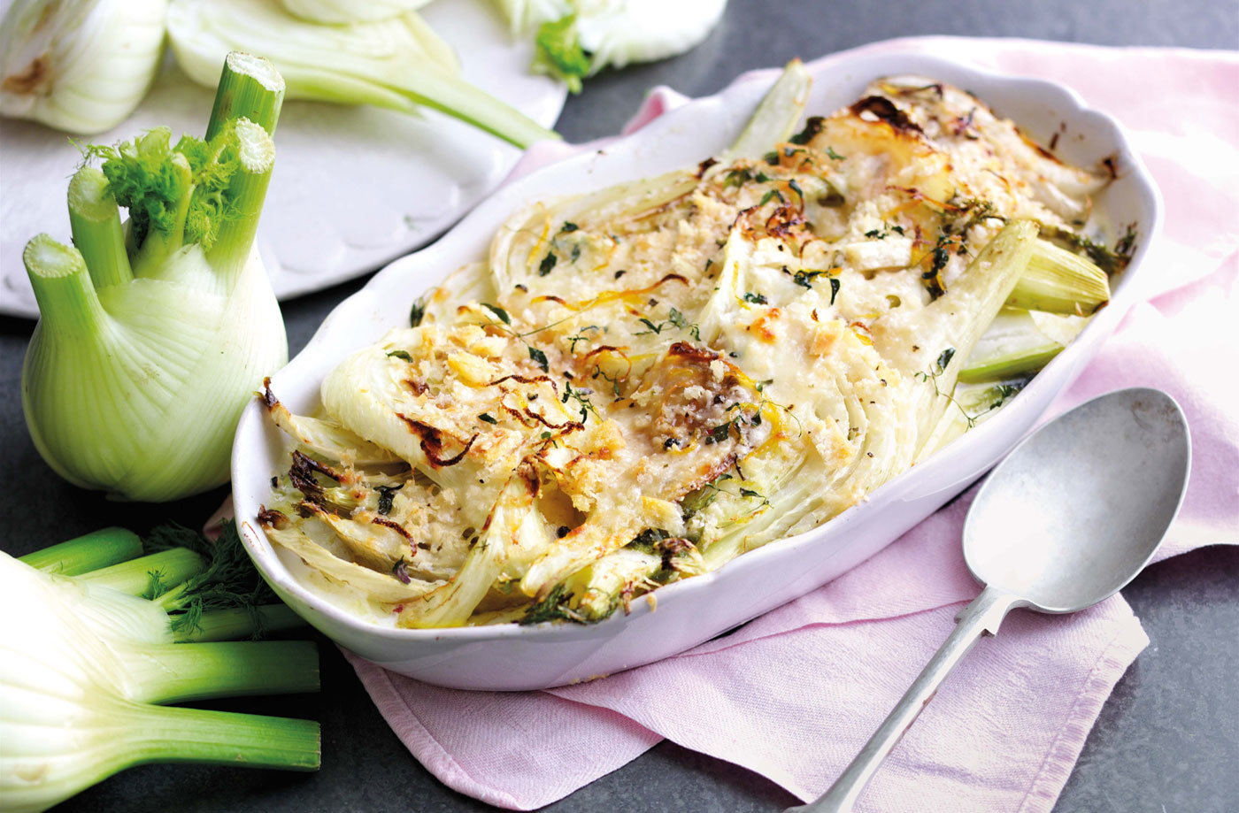
Milk-braised fennel with thyme breadcrumbs (V)
Serves 4, Kcals 148, Fibre 6.6g
- 10 mins to prepare and 40 mins to cook
- 1 tbsp olive oil
- 2 large fennel bulbs, thickly sliced
- 250ml (8 fl oz) whole milk
- 3 garlic cloves, finely sliced
- 4-5 sprigs fresh thyme, leaves picked
- 30g fresh white breadcrumbs
- 1 lemon, zested
- 25g (1oz) vegetarian hard cheese or Parmesan, finely grated

- Preheat the oven to gas 4, 180°C, fan 160°C.
- Heat the oil in a frying pan over a high heat. Add the fennel and cook, turning until lightly golden and just beginning to soften. Remove from the heat and set aside until needed.
- Meanwhile, pour the milk into a small pan set over a medium heat. Add the garlic and half the thyme leaves and bring to a simmer. Turn off the heat and leave to infuse for 4-5 minutes.
- Arrange half the fennel in a 1.5ltr (2 1/2pt) dish and pour over half the infused milk. Then add the remaining fennel and the remaining milk.
- In a bowl, combine the breadcrumbs, lemon zest, remaining thyme leaves, grated cheese and seasoning.
- Scatter the breadcrumb mixture over the fennel and bake for 30-35 minutes, until the fennel is tender and the topping golden. Leave to stand for 5-10 minutes before serving.

