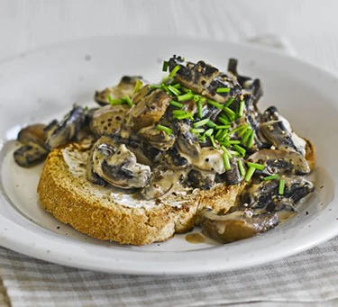Creamy mushrooms on toast (V)
Serves 1, Kcal 187, Fibre 3g
- 1 slice wholemeal bread
- 1 ½ tbsp light cream cheese
- 1 tsp rapeseed oil
- 3handfuls sliced, small flat mushrooms
- 2 tbsp skimmed milk
- ¼ tsp wholegrain mustard
- 1 tbsp snipped chives

- Toast the bread, then spread with a little of the cream cheese.
- Meanwhile, heat the oil in a non-stick pan and cook the mushrooms, stirring frequently, until softened.
- Spoon in the milk, remaining cheese and the mustard. Stir well until coated.
- Tip onto the toast and top with chives.

