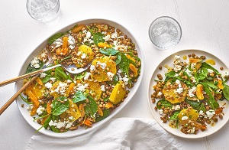Spiced lentil and spinach salad (V)
Serves 4
kcal367, Fibre 2.6g
- 1½ tsp cumin seeds
- 2 large oranges
- 2½ tbsp extra-virgin olive oil
- 1 tbsp red wine vinegar
- pinch of crushed chillies (optional)
- 2 x 400g tins green lentils, drained
- 10g fresh flat-leaf parsley, chopped
- 125g baby spinach
- 30g walnut halves, roughly chopped
- 100g soft dried apricots, sliced
- 75g reduced-fat salad cheese, crumbled

- Dry-fry the cumin seeds in a small frying pan over a medium heat for 1-2 mins, shaking the pan, until fragrant and a shade darker.
- Roughly crush with a pestle or the base of a sturdy jar.
- Slice the skin and white pith from the oranges, then slice the fruit into 1cm-thick rounds, reserving about 3 tbsp juice from the chopping board in a bowl.
- Whisk the oil and vinegar into the juice along with the crushed cumin seeds and chillies, if using. Season to taste.
- Mix the lentils and parsley with the baby spinach, walnut halves, orange slices and the sliced apricot.
- Toss with the dressing, transfer to a serving dish and scatter with the salad cheese.

Recipe from Tesco https://realfood.tesco.com/recipes/spiced-lentil-and-spinach-salad.html

