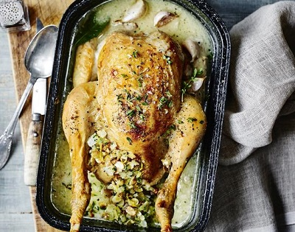
Almond milk chicken
Serves 6, Kcals 536, Fibre 2.8g

- 3 tbsp olive oil
- 1 onion, finely diced
- 75g flaked almonds
- 100g fresh breadcrumbs
- 1 tbsp chopped thyme leaves
- 2 tbsp fresh chopped parsley
- 2 lemons
- 1 medium egg
- 1 medium whole chicken
- 6 cloves garlic, with skin on
- 500ml unsweetened almond milk
- 2 tbsp cornflour

- Preheat the oven to 190°C/gas mark 5. Heat 1 tbsp of the oil in a pan and cook the onion for 8-10 minutes until soft.
- Meanwhile, in a frying pan, toast the flaked almonds for 1-2 minutes until golden, then set aside.
- Place the breadcrumbs, thyme, parsley, zest and juice of 1 lemon and the egg in a bowl and add the almonds and the softened onion. Season and mix well to combine until it comes together.
- Heat the remaining oil in a large, lidded, ovenproof pan. Brown the chicken all over, then carefully remove it from the pan and place the stuffing mixture in the cavity of the chicken along with ½ a lemon and 2 cloves of the garlic.
- Place it back in the pan, then add the remaining garlic cloves around it and season the chicken. Pour in the almond milk, put the lid on and place in the oven for 1 hour, basting occasionally.
- After 1 hour, remove the lid and cook for a further 30 minutes, until the chicken is completely cooked through.
- Transfer the chicken to a chopping board and cover it, then leave it to rest for 15 minutes. Meanwhile, mix the cornflour with 2 tbsp water until it makes a smooth paste.
- Place the pan with the almond milk sauce over a medium heat and whisk in the cornflour mixture. Simmer for 5 minutes or until thickened, then taste and season.
- Keep warm and serve with the chicken.

