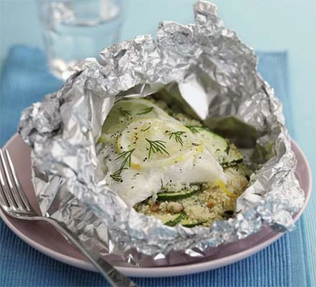Couscous & fish in a bag
Serves 1, kcals 552, fibre 2.1g
- 1 lemon
- 100g couscous
- 25g pine nut, toasted
- 1 small courgette, thinly sliced
- small handful dill, leaves only, chopped
- 150ml strong vegetable stock
- 1 haddock, or other white fish fillet

- Heat oven to 180C/fan 160C/gas 4.
- Fold a large sheet of foil or baking paper in half and tightly fold one side to seal.
- Grate the lemon zest and mix with the couscous, pine nuts, courgette and dill. Season well, then tip into the open ‘bag’.
- Cut the lemon in half, then cut 2 thin slices from one half. Juice the other half and add the juice to the stock.
- Lay the haddock on top of the couscous, top with the lemon slices, then carefully pour over the lemony stock.
- Fold the remaining open sides tightly.
- Bake for 20-25 mins, depending on how thick your fish is, until the fish is cooked and couscous is fluffy.

