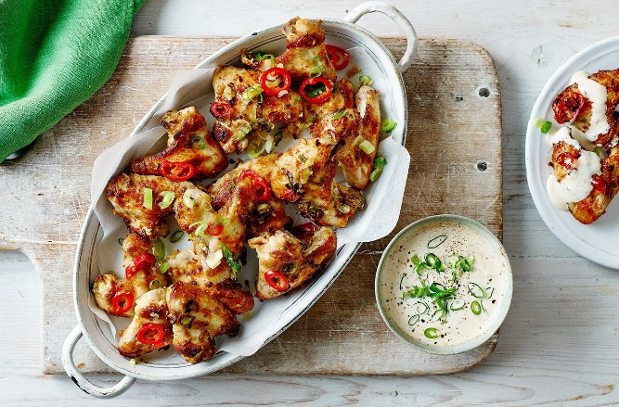
Salt and pepper chicken wings
Serves 4, Kcals 535, Fibre 1.4g
- 1kg-1.2kg pack chicken wings (about 16 wings)
- 1 tsp sesame oil
- 1 tsp Shaoxing rice wine or Japanese mirin
- 30g plain flour
- ½ tsp white pepper
- ¼ tsp ground ginger
- sunflower oil spray
- 1 red chilli, thinly sliced
- 2-3 cloves of garlic, chopped
- 2 spring onions, thinly sliced​
- For the dipping sauce
- 4 tbsp light mayo
- 100g natural yogurt
- 1 tbsp rice vinegar
- 1 tsp light soy sauce
- 1 tbsp caster sugar​
- 2 tsp mild curry powder

1. Preheat the air-fryer to 180°C.
2. In a large bowl, toss the chicken wings with the sesame oil and rice wine or mirin. Sprinkle over the flour, the white pepper, ground ginger, and some salt and black pepper, tossing until evenly coated.
3. Working in 2 batches, spray the basket of the air-fryer with a little oil and arrange half the chicken wings in a single layer with some space between them. Spray with oil and cook for 10 mins. (or using conversion chart cook in oven)
4. Tip into clean bowl and cook the next batch.
5. Put the sliced chilli, garlic and spring onion into the bowl with both batches of part-cooked chicken wings and shake to coat. Add everything from the bowl back into the air-fryer and cook for 10-15 mins, until dark golden brown and cooked through.
6. Meanwhile, stir together the ingredients for the dipping sauce, cover and chill for 10 mins before serving with the cooked chicken wings.

https://realfood.tesco.com/recipes/air-fryer-crispy-salt-and-pepper-chicken-wings.html

