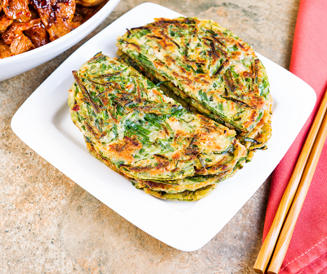Korean roasted vegetable pancakes (V)
Serves 4, kcals 294, Fibre 4.6g
- 250g assorted leftover roasted vegetables such as carrots, parsnips and sprouts; sliced into thin matchsticks or chopped into similar-size pieces
- ½ onion, sliced
- 1 red chilli, sliced, de-seeded if preferred
- sunflower oil, for frying
For the batter
- 100g plain flour
- 50g Brown Rice Flour
- 2 tbsp cornflour
- 1 tsp white granulated sugar
- ½ tsp baking powder
- ½ tsp sea salt flakes
- 1 tbsp soy sauce
For the dipping sauce
- 1 tsp sesame seeds, toasted
- 2 tbsp rice wine vinegar
- 2 tbsp soy sauce
- 2 tsp white granulated sugar
- 1 spring onion, finely chopped

- Put the dry ingredients for the batter in a mixing bowl. Stir briefly, then add the soy sauce and 220ml cold water. Whisk to break up any lumps; cover and chill for 30 mins. The batter will thicken slightly.
- Meanwhile, lightly crush the sesame seeds for the dipping sauce with a pestle and mortar or a sturdy bowl and the end of a rolling pin. Tip into a small bowl, then add 1 tbsp water and the rest of the dipping sauce ingredients. Stir and set aside.
- Stir the veg and onion into the batter. Heat 2 tbsp oil in a frying pan over a medium heat. Carefully ladle ¼ of the batter into the pan – you should hear it sizzle when it hits. Spread the batter thinly with the bottom of the ladle to make a pancake about 16cm wide, then scatter with some sliced chilli.
- Gently swirl the pan to move the oil around. After 2-3 mins, the top of the pancake will be partially cooked and the sides should have crisped up. Flip and add a little more oil, if needed, pressing the centre of the pancake a little. Fry for 2 mins more, or until golden and cooked through.
- Repeat to make 4 pancakes in total, then serve with the dipping sauce. Leftover pancakes can be kept chilled for up to 2 days; bring to room temperature before crisping up in a pan to serve.
- Tip: The plain batter, without the added veg, can be made up to 3 days ahead and kept in the fridge – just stir well before using.
- To reheat and serve, place on medium heat, stirring occasionally until the dish is heated through.

Recipe from Tesco
https://realfood.tesco.com/recipes/korean-roasted-vegetable-pancakes.html

