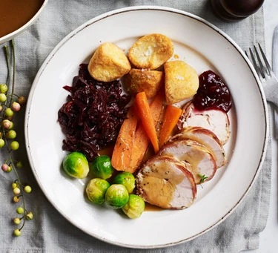
main
Slow-cooker turkey breasts with wine & bacon
Serves 8, Kcal 297 fibre 1g
If you like the idea of Christmas turkey but often find it dry, then you must try this. The tender turkey is wrapped in bacon then braised in a slow cooker
- 2 turkey breast fillets, approx. 800-900g each. Or buy 1 small turkey crown, approx. 1.9k and remove the breast fillets (your butcher will do this for you if you're unsure how to prepare)
- 16 rashers smoked streaky bacon
- 2 tbsp fresh thyme leaves, plus extra to serve if you like
- 1 tbsp sunflower oil
- 1 onion, halved and thickly sliced
- 2 carrots, sliced
- 2 bay leaves
- 15g dried porcini mushrooms
- 150ml dry white wine
- 500ml chicken stock (we used a Knorr chicken stock pot)
- 2 tbsp plain flour

- Lay a length of string twice the length of the turkey fillet on a chopping board. Arrange 4 more lengths of string large enough to tie around the width of the fillet at intervals across your first string, winding each one around the main string once so they don't move around too much.
- Lay 8 rashers of bacon, across the main string and running in the same direction as the 4 strings, overlap the rashers slightly so they don’t pull apart when you wrap the turkey.
- Scatter with 1 tbsp of the thyme and grind over some black pepper.
- Place a turkey fillet on top of the bacon then wrap the bacon around it and tie the strings around the middle and around the length to hold everything in place, it should be snug but not too tight Snip off any excess string with scissors.
- Heat the oil in a large frying pan and fry the fillet on all sides until browned then remove from the pan.
- While browning the first fillet wrap and tie the other one then brown that too. Set aside with the other breast.
- Add the onion and carrots to the pan and cook until starting to colour.
- Tip the vegetables into the slow cooker and add the bay leaves and mushrooms then arrange the turkey fillets on top.
- Pour the wine and stock into the frying pan, bring to a rapid boil then pour in to the slow cooker, cover and cook on LOW for 3-4 hours until a skewer poked into the centre comes out feeling very hot or a meat thermometer reads 75C.
- Lift the turkey breasts onto a plate and cover with foil.
- Mix the flour with 4 tbsp water to make a smooth liquid. Strain the cooking juices from the slow cooker into a pan, whisk in the flour mixture and keep whisking over the heat while bringing to a simmer to make a thin gravy.
- Serve with the sliced turkey breasts and traditional vegetables and accompaniments.
- If taking the turkey to the table on a platter, scatter with a little thyme and grind over some black pepper.

