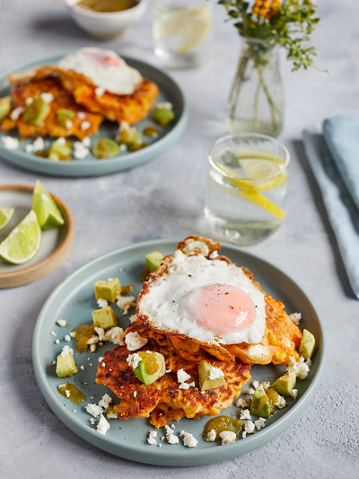
Sweet potato & sweetcorn pancakes (V)
serves 4, Kcals 520 Fibre 6.5g
- 500g sweet potatoes
- 1 x 200g tin of sweetcorn in water
- 150g self-raising flour
- 6 free-range eggs
- 50g feta cheese
- olive oil
- 1 x 220g jar of pickled jalapeños
- 2 limes
- 1 ripe avocado

- Preheat the oven to 130°C/250°F/gas ½.
- Scrub the sweet potatoes, prick with a fork and place in the microwave on high for 10 minutes, or until tender.
- Tip the sweetcorn (juices and all), into a large bowl. Add a tin’s worth of self-raising flour and crack in 2 of the eggs. Add a pinch of sea salt and black pepper, then whisk to a smooth batter. Break the sweet potatoes into large pieces and add to the batter, then crumble in half the feta and mix to combine.
- Place a large non-stick frying pan on a medium heat with 1 tablespoon of olive oil. Spoon 4 heaped tablespoons of the batter into the hot pan, shape into thick fritter-style pancakes, and cook for 2 to 3 minutes on each side, or until golden. Once cooked, transfer to the oven on a baking tray to keep warm while you make the next batch. Keep going until all the batter is used up.
- Tip the whole jar of jalapeños and brine into a blender, squeeze in the juice of one lime and blitz until smooth. Peel, destone and roughly chop the avocado and place in a bowl, then dress with a little of the jalapeño sauce and mix well.
- Place the frying pan back on a medium heat with 1 tablespoon of olive oil, then crack in the remaining eggs and fry to your liking.
- Stack the fritters on two plates, top each stack with a fried egg and spoon over the dressed avocado and crumble over the remaining feta. Finish with an extra drizzle of the spicy jalapeño sauce and a wedge of lime, and deliver!

https://www.jamieoliver.com/recipes/pancakes/sweet-potato-sweetcorn-pancakes/

