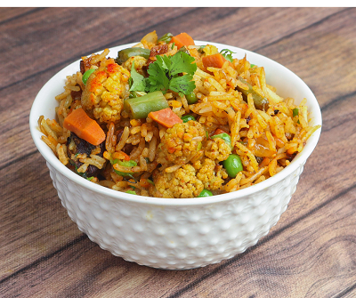Bubble and squeak biryani (V)
Serves 6, kcals 329, Fibre 5.9g
- 1 red onion, peeled and finely sliced into rounds
- 1 tsp white wine vinegar
- 1 tsp sugar
- 1 onion, peeled and sliced
- 2 garlic cloves, crushed
- 1 inch stick ginger, peeled and crushed
- 2 tsp garam masala
- 1 tsp turmeric
- 400g basmati rice
- 900ml hot chicken or vegetable stock
- 700g leftover veg: Brussel sprouts, cabbage, chopped potatoes, roast carrots, parsnips
- bunch 15g coriander, chopped
- poppadom’s, to serve
(IF YOU DON'T HAVE RED ONIONS, TRY USING WHITE, BROWN OR SPRING ONIONS)

- Start by pickling the onions. Toss the onion rounds in the vinegar and sugar and add a pinch of salt. Set aside.
- Heat the oil in a medium saucepan with a tight-fitting lid. Cook the onion over a medium heat for a few mins until just browning, then add the garlic, ginger, garam masala and turmeric. Cook for another few minutes. Stir in the rice, give everything a good mix to coat the rice evenly.
- Add the vegetables and pour over the stock and cover with a layer of tin foil, then tightly fit the lid. Cook over a medium heat for 10 mins, then turn off the heat and leave to steam for another 5 mins.
- Remove the lid, stir through the coriander and top with the pickled onions. Serve with crunchy poppadom’s.

Recipe from Tesco
https://realfood.tesco.com/recipes/bubble-and-squeak-biryani.html

