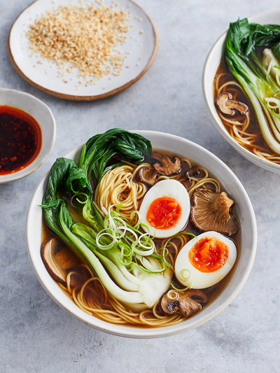
Mushroom ramen (V)
serves 4, Kcals 370 fibre 3.9g
- 400g mushrooms
- 6cm piece of ginger
- 1 bunch of spring onions
- 4 cloves of garlic
- olive oil
- 2 tablespoons reduced-salt soy sauce
- 1.5 litres organic vegetable stock
- 4 large free-range eggs
- 300g fine free-range egg noodles
- 2 pak choi
- optional: sesame seeds
- optional: chilli sauce

- Preheat the oven to 180°C/350°F/gas 4.
- Finely slice the mushrooms and place in a large roasting tray. Peel and finely slice the ginger, trim and slice the spring onions, reserving the green tops, and peel and bash the whole garlic cloves. Add everything to the roasting tray, mix with 1 tablespoon of olive oil and a pinch of sea salt and black pepper. Roast for 30 mins or until gnarly.
- Remove the tray from the oven, add the soy sauce and pour over 200ml of the hot stock, scraping all the sticky bits up from the bottom of the tray. Transfer everything to a large saucepan with the remaining stock and simmer on a low heat.
- Meanwhile, boil the eggs in a large pan of boiling water for 6 minutes. Remove the eggs using a slotted spoon and cool slightly under running water. Peel the eggs and cut them in half. Cook the noodles in the egg water to pack instructions, then remove to serving bowls with tongs. Blanch the pak choi for 1 minute in the noodle water, drain and slice in half lengthways.
- To serve, add 2 egg halves and half a pak choi to each bowl. Ladle over the broth. Scatter over the reserved spring onion tops, and sesame seeds and chilli sauce, if you like.

https://www.jamieoliver.com/recipes/mushroom/my-kinda-mushroom-ramen/

