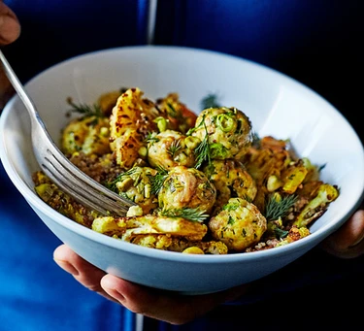Chicken meatballs with quinoa & curried cauliflower
Serves 1, kcals 697, fibre 9g
- 250g chicken mince
- 1 garlic clove, finely chopped
- 1 tsp turmeric
- pinch of cumin
- pinch of cinnamon
- handful dill, finely chopped
- 2 spring onions, finely chopped
- For the quinoa & curried cauliflower
- 50g quinoa
- 4 cauliflower florets
- 25g sweet potato, chopped
- 1 tbsp olive oil
- 1 tbsp medium curry powder
- 1 tsp pistachios, chopped
- 1 tsp sultanas
- ½ lime, juiced

- For the meatballs, mix together all the ingredients in a bowl with some seasoning.
- Form into six balls and chill in the fridge for 20 mins.
- Heat oven to 200C/180C fan/ gas 6.
- Wash the quinoa and put it in a saucepan with 100ml water.
- Bring to the boil, then turn down to a gentle simmer and cook for 10-15 mins or until doubled in size and tender.
- Drain and set aside to cool.
- Put the cauliflower and sweet potato in a roasting tin and toss in the oil and curry powder.
- Put the meatballs in a separate tin. Cook both in the oven for 15 mins or until cooked through.
- Mix the quinoa with the cauliflower, sweet potato, pistachios and sultanas, squeeze over the lime juice, then serve with the meatballs.

