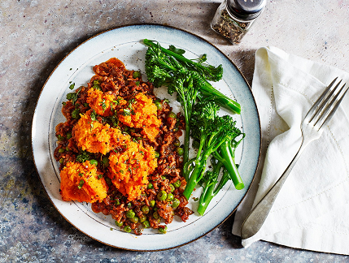Moroccan-spiced shepherd’s pie
Serves 1, kcals 554, fibre 15.5g
- ½ tbsp vegetable oil
- ½ 250g pack lamb mince
- 1 onion, finely chopped
- 2 garlic cloves, crushed
- 1 tsp ground cumin
- 1 tsp ground cinnamon
- 1 tbsp tomato purée
- 1 chicken stock cube, made up to 300ml
- 50g frozen garden peas
- 15g coriander, finely chopped
- 1 medium sweet potato, peeled and cut into 2cm chunks
- 100g Tenderstem broccoli

- Preheat the oven to gas 6, 200°C, fan 180°C.
- Heat the oil in a frying pan over a high heat. Add the lamb, breaking it up with the back of a wooden spoon and fry for 5 mins until starting to crisp. Add the onion and fry for a further 5 mins before adding the garlic, cumin, cinnamon and tomato purée. Cook for 2 mins until fragrant. Mix in the stock, bring to the boil and simmer for 10 mins until reduced by half. Stir through the peas and the coriander, saving a little to garnish, and season to taste.
- Meanwhile, bring a pan of salted water to the boil. Add the sweet potato and simmer for 15 mins until soft. Drain, return to the pan and mash with a pinch of salt and pepper until smooth.
- Spoon the lamb filling into a small ovenproof dish and top with the sweet potato. Place on a baking tray and bake for 25 mins until golden and bubbling.
- After the shepherd’s pie has been cooking for 15 mins, place the broccoli in a steamer and cook for 10 mins until bright green and tender.
- Serve the shepherd’s pie with the broccoli, sprinkled with the remaining coriander.

