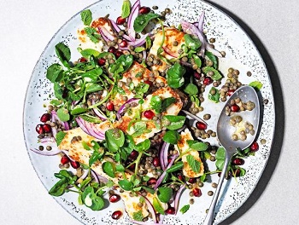
Lemony lentil salad with griddled halloumi (V)
Serves 4, Kcals 419, Fibre 10.2g
For the dressing
- 2 tbsp olive oil
- 1 lemon, juiced
- 1 tsp Dijon mustard
- 14g fresh mint, leaves picked and roughly chopped

For the salad
- 500g cooked puy lentils
- 1 small red onion, halved and very finely sliced
- 100g pomegranate seeds
- 80g watercress
- 225g light halloumi, cut into ½cm slices

- Combine the olive oil, lemon juice, mustard and mint and season. Place the puy lentils, onion, half the pomegranate seeds and the watercress in a large bowl and toss with the dressing.
- Heat a griddle pan over a high heat and add the halloumi, cooking for 1-2 minutes on each side so that it has deep golden griddle marks all over.
- Lay the lentil mixture out over a large platter, then top with the halloumi pieces and remaining pomegranate seeds to serve.

https://www.sainsburys.co.uk/gol-ui/recipes/lemony-lentil-salad-with-griddled-halloumi

