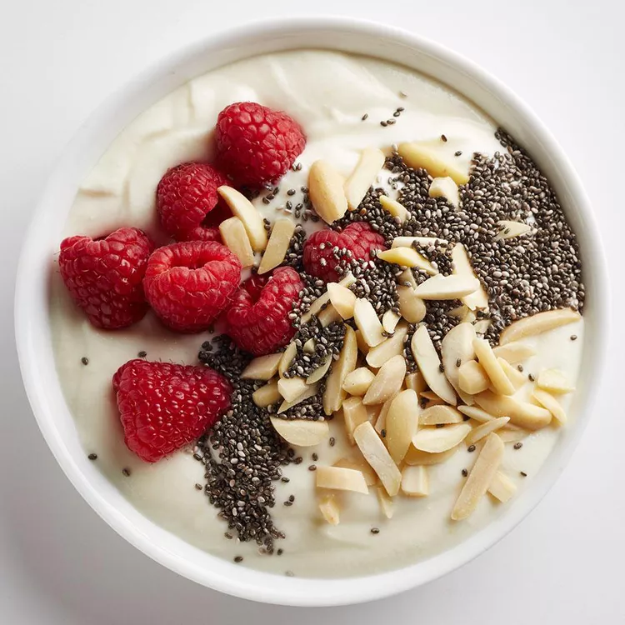Ricotta & Yogurt Parfait (V)
Serves 1, kcals 272, fibre 1g

- 200g fat free vanilla Greek yogurt
- 50g ricotta
- ½ teaspoon lemon zest
- 1 large handful raspberries
- 1 tablespoon slivered almonds
- 1 teaspoon chia seeds

- Combine yogurt, ricotta and lemon zest in a bowl.
- Top with raspberries, almonds and chia seeds.

