Side
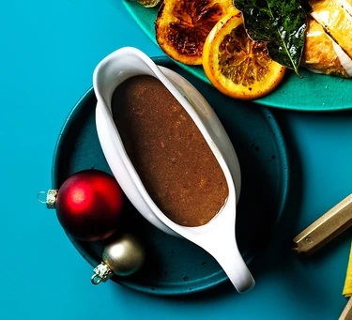
No-waste gravy
Serves 6 – 8, Kcals 126, Fibre 0.3g
A rich tasty gravy that uses all the bits you would normally throw away

ingredients
- 3 tbsp sunflower oil
- 1 reserved chicken backbone, chopped or snapped into pieces
- carrot trimmings and peels, finely chopped
- ½ large onion, plus the whole skin
- 1 tsp caster sugar
- 3 tbsp plain flour
- 1 tbsp soy sauce (optional)
- 100ml wine port or sherry (or use water)
- 2 chicken or beef stock cubes or pots

- Heat the oil in a wide, shallow pan over a medium heat and spend at least 10 mins browning the chicken backbone pieces – the darker the colour, the more flavourful the gravy will be.
- Add the carrot trimmings, onion and onion skins, and cook for 3-4 mins over a high heat until well browned.
- Scatter over the sugar and cook until it starts to caramelise, then tip in the flour and cook to a sticky, light brown paste.
- Splash in the soy sauce, if using, then pour in the wine or water and simmer for a few minutes until reduced and thickened.
- Stir in 1 litre water from the kettle, add the stock cubes and bring to a simmer. Cook gently for 40 mins, then sieve into another saucepan and season to taste.
- Stir in any resting juices from the roast.
- Reheat when ready to serve. Can be made a day ahead and chilled, then reheated the next day.

