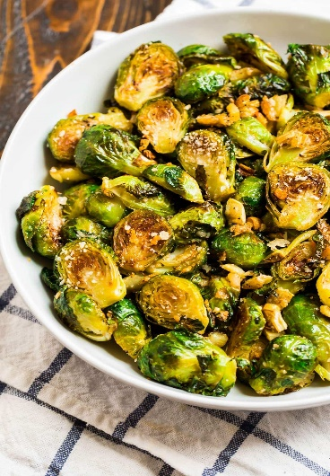
Side
Garlic butter sprouts (V)
Serves 4-6. Kcals 146. Fibre 4.7g
- 80g salted butter
- 500g brussels sprouts, any discoloured outer leaves removed and halved
- 5 garlic cloves
- Splash cider vinegar or lemon juice
- Melt the butter in a large frying pan over a low-medium heat. Add the sprouts and cook slowly in the foaming butter for around 25 minutes, stirring occasionally. You want them to crisp up and get a nice, deep caramelisation.
- Finely grate the garlic cloves into the sprouts, then cook for a further 5 minutes until the garlic has infused all its flavour into the remaining butter. The sprouts should be crispy on the outside and meltingly tender inside. Taste and season with salt and vinegar or lemon juice.

