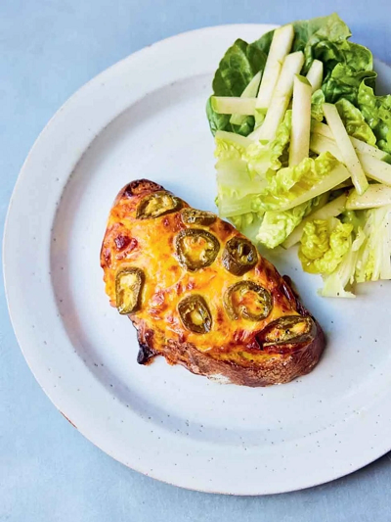
Punchy Welsh rarebit (V)
serves 2, Kcals 325 Fibre 2.8g
- 2 large slices of good bread (1½cm-thick)
- 1 free-range egg
- 50g Red Leicester or Cheddar cheese
- 1 tbsp half-fat crème fraîche
- 1 heaped tsp English mustard
- 25g jarred sliced jalapeños
- 1 eating apple
- 1 little gem lettuce
- extra virgin olive oil
- red wine vinegar
- optional: Worcestershire sauce

- Place the bread in the air-fryer drawer and toast for 5 minutes at 200ºC.
- Whisk the egg in a bowl until light and foamy, then finely grate in the cheese, add the crème fraîche, mustard and a pinch of black pepper, and mix well.
- Remove the bread from the air fryer, flip over, spoon the rarebit mixture over both pieces, then gently poke in the jalapeño slices. Return to the drawer and cook for 5 minutes at 200ºC, or until golden and bubbling.
- While it cooks, finely slice the apple into rounds, then across into matchsticks. Click the outer leaves off the lettuce, finely slice the inner base, and slice the inner tender leaves. Gently toss it all in a little extra virgin olive oil, red wine vinegar and seasoning, and plate up with the rarebit, add a shake of Worcestershire sauce, if you like, and enjoy!

Top Tip
Feel free to swap in any good melty cheese of your choice

https://www.jamieoliver.com/recipes/cheese/air-fryer-punchy-welsh-rarebit/

