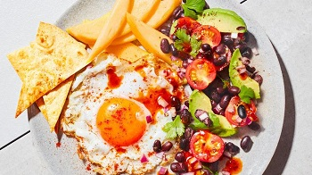
Mexican-inspired mango, avocado and black bean salad (V)
Serves 4, Kcals 393, Fibre 10.1g
- 1 plain tortilla wrap
- 50 ml olive oil, plus ½ tsp
- ½ tsp smoked paprika
- 1/8 tsp cayenne
- 380 g carton black beans, rinsed and drained
- 1 avocado, diced
- 10 cherry tomatoes, cut in half
- ½ red onion, finely diced
- 15 g coriander, roughly chopped
- 2 limes, juiced
- 3 tsp chipotle paste
- 1 tsp runny honey
- 1 mango, peeled and cut into thin wedges
- 4 medium eggs

- Preheat your oven to 200°C/fan 180°C/gas mark 6. Brush the tortilla with the ½ tsp olive oil, then cut into 16 triangles. Place on a baking tray and bake in the oven for 5 minutes until lightly golden. Pour into the bowl and toss with the paprika and cayenne.
- Meanwhile, toss the black beans with the avocado, cherry tomatoes, red onion, coriander and juice of ½ lime, seasoning well.
- In a medium bowl, add the juice of 1½ limes, the chipotle paste and the runny honey, whisking together. Set aside 2 tbsp oil and slowly drizzle in the rest, whisking continuously until emulsified.
- In a large frying pan, heat 1 tbsp oil over a high heat. Once hot, crack in two eggs. Lower the heat to medium high and continue to cook until the white is set and crispy underneath but the yolk is still runny. Transfer to a kitchen towel-lined plate and repeat with the last 1 tbsp oil and the remaining eggs.
- Serve the eggs with the black bean salsa, wedges of mango and tortilla chips, and drizzle over the dressing.

https://www.sainsburys.co.uk/gol-ui/recipes/mexican-inspired-mango-avocado-and-black-bean-salad

