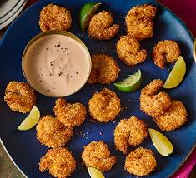
Coconut king prawns with chilli mango mayo
Serves 4-6, kcal273, fibre4g
- 5 tbsp desiccated coconut
- 5 tbsp panko breadcrumbs
- 1-2 tbsp rapeseed or sunflower oil
- 3 tbsp plain flour
- 1 tsp smoked paprika
- 200g raw extra-large king prawns thawed if frozen
- 1 egg beaten

For the chilli mango mayo
- 100g fresh mango chunks
- 1 mild red chilli deseeded and roughly chopped
- 3 tbsp mayonnaise
- 1 lime plus, extra wedges to serve

- Begin with the mayo. Blend the mango and chilli together until smooth, then stir into the mayonnaise. Season and add a squeeze of lime to taste.
- Stir the coconut and breadcrumbs together, then gradually add the oil, using your fingertips to rub the crumbs. Make sure you add enough oil to coat evenly, without causing any clumping. Set the coconut crumbs aside.
- Heat the air fryer to 200C. Dip the prawns into the seasoned flour, then the beaten egg and finally the coconut crumbs. Shake off any excess, then cook directly in the air fryer basket for 6-8 mins, turning halfway, until crunchy and lightly golden.
- Serve with the mayo and extra lime wedges.

