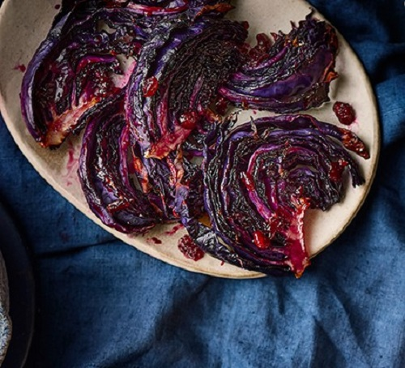
Red cabbage wedges (V)
Serves 4, kcal 134, fibre 4g
- 1 small red cabbage any bruised leaves removed
- 3 tbsp vegetable oil
- 4 tbsp cranberry sauce
- 2 tbsp red wine vinegar
- 2 tsp thyme leaves

- Trim the base of the cabbage, then cut in half through the core. Using the core to keep the wedges intact, cut each half into 3-4 thin wedges. Use 2 tbsp of the oil to brush the wedges on each side and season well.
- Transfer to the air fryer, in a single layer if they’ll fit, or with the thinner middle parts overlapping rather than the thicker outside parts if not. Roast at 190C for 30-40 mins until the cores are tender when pierced with a fork.
- In a small bowl, whisk the remaining oil with the cranberry sauce and vinegar until combined. Brush the wedges with the glaze, flip over and glaze the other side.
- Drizzle the rest of the glaze over the top. Roast for another 5-10 mins until sticky. Scatter with the thyme to serve.

