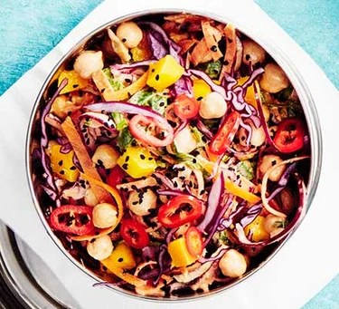Curried mango & chickpea pot (V)
Serves 1, kcals 327, Fibre 13g
- 200g chickpeas, drained and rinsed
- 2 tbsp Greek yogurt
- ½ lemon, juiced
- 1 heaped tbsp korma curry paste
- ½ carrot, julienned or grated
- 70g red cabbage, shredded
- 50g baby spinach, shredded
- 40g mango, finely diced
- ½ tsp nigella seeds
- ½ small red chilli, finely sliced (deseeded if you want less heat)

- Combine the chickpeas, yogurt, lemon and korma paste in a bowl, then toss with the carrot, cabbage, spinach and mango.
- Tip into a serving bowl scatter with the nigella seeds and red chilli.

