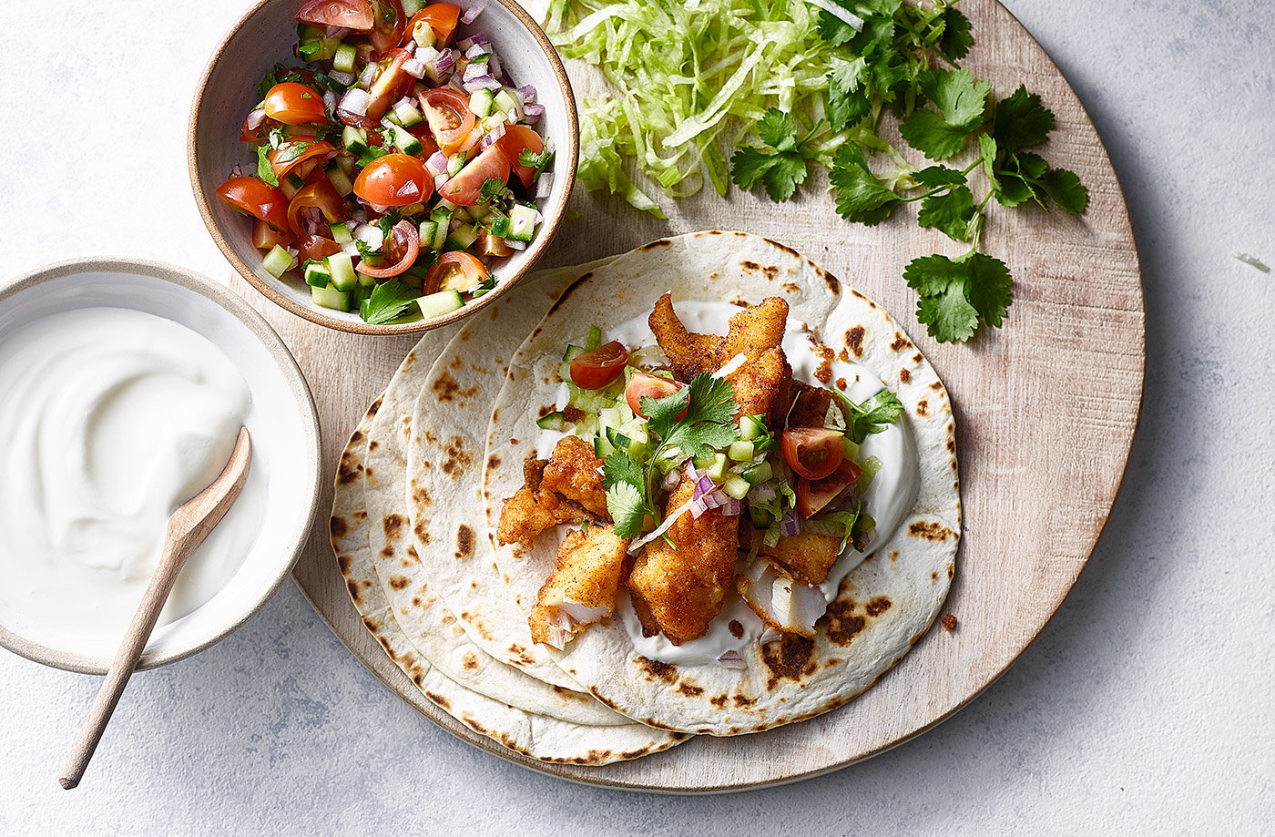Harissa fish tacos
Serves 4, Kcals 526, Fibre 4.8g
- 520g pack white fish fillets, (if frozen defrost)
- 50g plain flour
- 1 tbsp harissa seasoning
- 4-6 tbsp vegetable oil, for frying
- 8 mini tortilla wraps
- ½ red onion, finely chopped
- 100g cherry tomatoes, quartered
- 1 cucumber portion, diced
- 15g fresh coriander, chopped
- 1 tsp olive oil
- ½ iceberg lettuce, shredded
- 150g Greek-style yogurt

- Pat the fish dry with kitchen paper, then cut into 1cm-thick strips. Mix the flour harissa and some seasoning on a plate, then toss the fish in it until well coated.
- Pour enough vegetable oil into a shallow, nonstick frying pan to cover the base and heat over a medium-high heat. Fry the fish in batches for 2-3 mins each side until golden, crisp, cooked through and flaky in the middle. Transfer to a plate lined with kitchen paper; set aside.
- Meanwhile, heat a dry frying pan over a high heat and toast the tortillas for 1-2 mins each side until lightly charred. Wrap in foil to keep warm until ready to serve.
- Mix the onion, tomatoes, cucumber and half the coriander in a bowl with a pinch of salt and the olive oil. Put the lettuce, remaining coriander and yogurt in separate bowls and serve everything at the table to let everyone help themselves to fish and toppings.

https://realfood.tesco.com/recipes/harissa-fish-tacos.html

