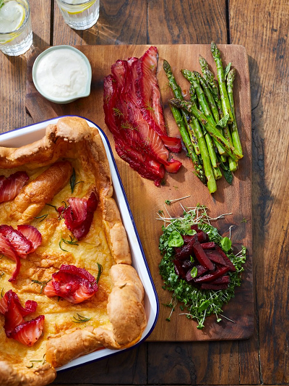
Mega Yorkie
serves 8, kcals 311, fibre 2.3g
- 150g plain flour
- 150ml whole milk
- 4 large free-range eggs
- vegetable oil
- 3 or 4 sprigs of fresh rosemary
- 180g quality smoked salmon,
- 2 bunches of asparagus (600g)
- 1 lemon
- 500g vac-packed cooked beetroot
- 8 tablespoons balsamic vinegar
- 2 heaped teaspoons runny honey or maple syrup
- 4 punnets of cress
- 4 sprigs of fresh basil

DRESSING
- 6 heaped tablespoons fat-free natural yoghurt
- 4 heaped tablespoons jarred grated horseradish
- 2 lemons

- Place the flour, milk and a pinch of sea salt into a bowl, crack in the eggs, add 50ml of cold water and whisk vigorously to a smooth batter. Pour into a jug and place in the fridge to relax until needed (I like to make mine the day before).
- When you’re almost ready to cook, preheat the oven to 200ºC/400ºF/gas 6.
- Drizzle 4 tablespoons of vegetable oil into a 35cm x 25cm roasting tray, pick in the rosemary leaves and place in the oven to get hot (make sure that the shelf is lowered so the Yorkshire has room to rise).
- Quickly but carefully remove the oiled tray from the oven, spread out the rosemary, then pour in the batter and return to the oven to cook for 25 minutes, or until puffed up and golden – don’t be tempted to open the oven door during that time!
- Meanwhile, put a medium griddle pan on a high heat. Trim the asparagus, place in the pan and dry fry, turning until nicely charred on all sides, then transfer to a bowl, squeeze over the lemon juice and season with salt and black pepper.
- Put a casserole pan on a medium heat. Drain and slice or dice the beetroot, then place in the pan with the balsamic and honey and cook until sticky, stirring regularly.
- Mix the yoghurt and horseradish in a bowl, then season to taste with salt, pepper and lemon juice. Snip the cress onto a serving board, spoon the beetroot on top, then pick over the basil leaves. Pile the asparagus on the board.
- Once cooked, slide the Yorkie on to the board, then roll the salmon into roses and place on top. Serve straight away with lemon wedges on the side.

https://www.jamieoliver.com/recipes/egg/mega-yorkie/

