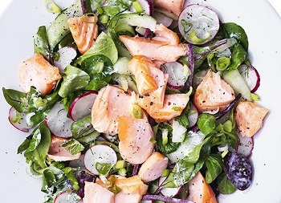
Salmon, cucumber and radish salad
Serves 4, Kcals 301, Fibre 2.4g
For the dressing
- 100g low-fat Greek yogurt
- ½ lemon, juiced
- 2 tbsp fresh dill
For the salad
- 2 x 240g smoked salmon fillets
- 1 cucumber
- 200g radishes
- 120g bistro salad
- 2 tbsp fresh mint leaves, roughly chopped
- 3 spring onions, sliced, to serve

- Preheat the oven to 200°C/fan 180°C/gas mark 6. Put the salmon fillets on a baking tray and cook according to the instructions on the packet.
- Meanwhile, peel the cucumber into long thin strips using a vegetable peeler, and discard the watery core. Slice the radishes into rounds.
- Combine the yogurt, lemon juice and dill with a little seasoning. Toss together the salad leaves, cucumber, radishes and mint leaves with almost all the dressing. Transfer to a large serving platter. Flake the salmon on top and add the remaining dressing and spring onions.

https://www.sainsburys.co.uk/gol-ui/recipes/salmon-cucumber-and-radish-salad

