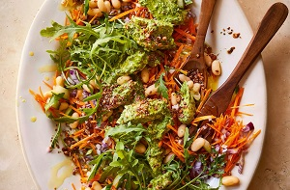
Green tahini chicken & cannellini bean salad
Serves 2: Kcals 590, Fibre 15g
- ½ x 400g pack Chicken Mini Fillets
- 25g pack flat leaf parsley
- 25g pack coriander
- 2 cloves garlic
- 30g tahini
- ½ lemon, juice
- 400g can cannellini beans, drained and rinsed
- ½ cucumber, diced
- 1 carrot, peeled and coarsely grated
- 1 small red onion, finely chopped
- 50g wild rocket
- Extra Virgin Olive Oil, to drizzle (optional)

- Place the chicken in a small saucepan and cover with cold water. Add a pinch of salt, bring to the boil, then simmer gently for 8-10 minutes until completely cooked through, the juices run clear and there is no pink meat. Drain well, then once cool enough to handle, tear or chop into bite sized pieces and place into a bowl.
- Meanwhile, to make the green tahini dressing, set aside a few of the herbs to garnish, then place the rest in a blender with the garlic, tahini, lemon juice, 3 tbsp cold water and a pinch of salt and whizz until very smooth. Check the seasoning, then pour the dressing over the chicken. Cover and chill until ready to serve.
- Stir together the beans, cucumber, carrot and red onion
- Divide the rocket, bean salad and green tahini chicken between two bowls. Scatter over the reserved herbs, drizzle with olive oil if liked, then serve.

Cook’s tip
For the juiciest texture (and if time allows), leave the chicken to cool completely in the water before draining. Or if you have any leftover roast chicken, this is a delicious
way to use it up.

Recipe from Waitrose - https://www.waitrose.com/ecom/recipe/green-tahini-chicken-and-cannellini-bean-salad

