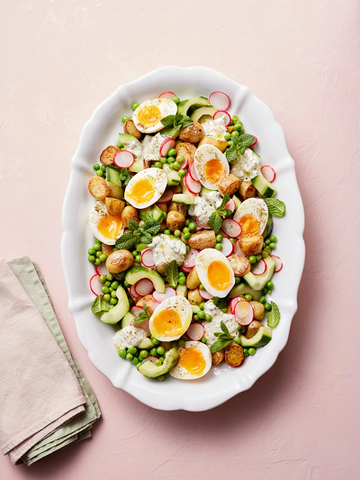
Crispy potato & egg salad (V)
serves 4, Kcals 466, Fibre 7.1g
- 1kg new potatoes
- olive oil
- 4 large free-range eggs
- 1 cucumber
- 100g radishes
- red wine vinegar
- 300g frozen peas
- 8 tablespoons Greek yoghurt or crème fraîche
- 2 teaspoons Dijon mustard
- extra virgin olive oil
- 1 bunch of fresh soft herbs, such as mint, dill, parsley (30g)

- Scrub and chop the potatoes into 2cm chunks, then place in a large non-stick pan on a medium heat with 2 tablespoons of olive oil. Season with sea salt and black pepper and cook for 20 minutes, or until golden and cooked through, stirring regularly.
- Meanwhile, put the eggs in a medium pan, cover with cold water, then place on a high heat and bring to the boil. Reduce the heat to low and simmer for 6 minutes. Peel the cucumber, then cut it in half lengthwise, remove the seeds and thickly slice on an angle. Trim and finely slice the radishes, then place it all in a bowl with a splash of red wine vinegar and a pinch of salt, and set aside to pickle.
- When the time is up on the eggs, carefully remove them into a bowl of ice-cold water. Add the frozen peas to the pan of boiling water and cook for 2 minutes, then drain and refresh under cold water. Add the peas to the pickling bowl.
- In a small bowl, mix together the yoghurt, mustard, 1 tablespoon of extra virgin olive oil and 2 tablespoons of red wine vinegar. Finely chop most of the herb leaves, reserving a few small ones for later, then add to the bowl and season.
- To serve, tip the hot potatoes onto a serving dish, then make a well and place the drained pickled veg in the centre. Peel the eggs, cut in half and dot over the top. Dollop over the yoghurt dressing and scatter over the remaining herbs.

https://www.jamieoliver.com/recipes/potato/crispy-potato-egg-salad/

