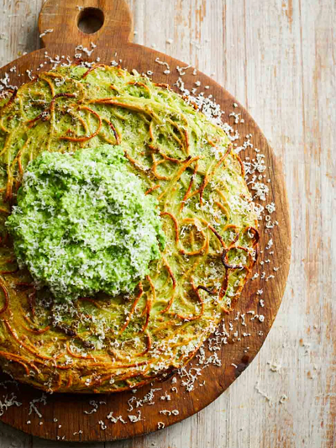
Spaghetti frittata (V)
serves 6, Kcals 502 fibre 6.4g
- 300g dried spaghetti
- 500g frozen peas
- 1 bunch of fresh mint (30g)
- 2 cloves of garlic
- 50g ground almonds
- optional: 75g Cheddar cheese, plus extra to serve
- extra virgin olive oil
- 6 large free-range eggs

- Preheat the oven to 220°C/425°F/gas 7.
- Cook the pasta in a large pan of boiling salted water according to packet instructions, then drain and tip back into the pan.
- Meanwhile, make the peasto. Cook the peas according to packet instructions in the microwave (or in a pan of boiling salted water), then place in a food processor. Pick in the mint leaves, peel and add the garlic, and tip in the ground almonds. Break in the cheese, drizzle in 4 tablespoons of extra virgin olive oil and blitz. Taste, then season to perfection with sea salt and black pepper.
- Toss most of the peasto into the spaghetti pan. Crack in the eggs, beat together with the peasto, and mix into the spaghetti with a pinch of salt and pepper.
- Put a 28cm non-stick ovenproof frying pan on a high heat. Tip in the spaghetti mixture, pressing it down with your spatula and letting it sizzle for 1 minute, then transfer to the oven for 25 minutes, or until puffed up and golden.
- Carefully turn out, and serve with dollops of the remaining peasto and grate over a little extra cheese, if you like. Delicious with a zingy green salad on the side.

https://www.jamieoliver.com/recipes/pasta/spaghetti-frittata

