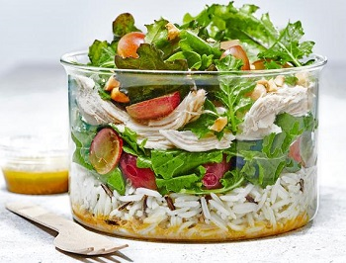
Epic roast chicken salad with wild rice and grapes (V)
Serves 2. Kcals 479, Fibre 2.4g
- 120g basmati rice
- 20g hazelnuts, blanched
- 40g mixed baby kale
- 60g red grapes, halved
- 150g cooked chicken

For the dressing
- 2 tbsp balsamic vinegar
- 1 tbsp extra virgin olive oil
- 1 tsp Dijon mustard
- ½ tbsp fresh rosemary, roughly chopped
- 1 tsp runny honey

- Preheat the oven to 200°C/fan 180°C/gas mark 6. Bring a large pan of water to the boil and cook the rice according to the instructions on the packet. Drain and leave to cool.
- Place the hazelnuts on a small roasting tray and roast for 8-10 minutes, until lightly golden. Set aside to cool, then roughly chop. Mix the cooled rice with the kale, half the grapes and seasoning.
- Place the balsamic, olive oil, mustard, rosemary and honey in a mini food processor and blitz for 1 minute until everything is well mixed and the dressing has thickened slightly. Divide the dressing between the bottom of two mason jars, then add the chicken. Add the rice, then top with the chopped hazelnuts and remaining grapes.

https://www.sainsburys.co.uk/gol-ui/recipes/epic-roast-chicken-salad-with-wild-rice-and-grapes

