Main
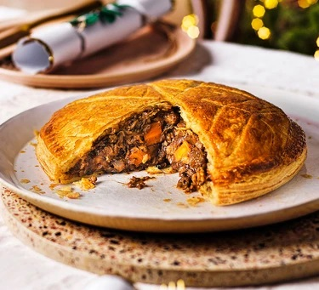
Mushroom bourguignon pithivier (V)
Serves 6 – 8, Kcals 300, Fibre 3g
- 250g chestnut mushrooms, roughly chopped
- 150g portobello mushrooms, roughly chopped
- ½ tbsp vegetable oil
- 2 shallots, peeled, trimmed and quartered lengthways
- 1 carrot, roughly chopped
- 3 thyme sprigs, leaves picked
- 1 garlic clove, crushed
- ½ tbsp tomato purée
- 1½ tbsp plain flour, plus extra for dusting
- 125ml red wine (check it's vegan)
- 250ml vegetable stock
- 500g puff pastry block
- milk, for glazing

- Cook the mushrooms in a large saucepan, covered, for 5 mins. Remove the lid so the liquid can evaporate, about 15 mins.
- Add the oil and fry the mushrooms for 5-6 mins until golden. Remove to a bowl with a slotted spoon, leaving any excess oil behind, and set aside.
- Fry the shallots for 6-8 mins until beginning to brown, then add the carrot, thyme leaves and garlic, and fry for 1 min. Add the tomato purée and flour, mix well and cook for 1-2 mins.
- Pour in the wine, stir and simmer for 3-4 mins until the alcohol has evaporated.
- Pour in the stock and cook for 15-20 mins more until the shallots and carrots are almost tender.
- Return the mushrooms to the pan and cook for 10-15 mins more until everything is cooked through, the liquid has almost evaporated and the sauce is thick. It’s important that you cook the liquid down until thick, or it will be difficult to shape later.
- Remove from the heat and leave to cool for 1 hr until cold.
- You can make the filling up to three days ahead and chill.
- Heat the oven to 200C/180C fan/gas 6.
- Cut off a third of the pastry block and roll out on a lightly floured surface to a 5mm-thick square. Put on a sheet of baking parchment. Spoon the cooled veg mixture into the centre piling it up high.
- Roll out the larger pastry block as before, ensuring the square is enough to cover the base.
- Brush the exposed pastry on the base around the mushroom filling with milk, then lay the larger pastry square on top to enclose the filling.
- Press around the edges to seal, then trim the edges so you end up with an 18cm circle with the filling in the middle.
- Score lines or patterns into the top of the pastry, being careful not to cut all the way through. Brush all over with milk, then bake for 30-40 mins until the filling is hot and the pastry is puffed up and golden.

