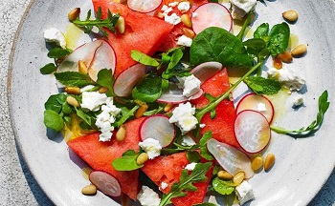
Juicy watermelon, feta and mint salad (V)
Serves 4, Kcals 266, Fibre 2.9g
For the salad
- 650g watermelon, cut into triangles
- 400g radishes, thinly sliced
- 80g bag watercress, spinach and rocket salad
- 15g fresh mint, roughly chopped
- 150g feta
- 35g pine nuts, toasted
For the dressing
- 1 tbsp extra virgin olive oil
- 1 lemon, juiced and zested
- 1 tsp honey

- In a large bowl, mix together the watermelon, radishes, salad leaves and mint.
- Whisk the olive oil, lemon juice, half the lemon zest and the honey together and pour over the salad.
- Toss to combine well. Transfer to a serving platter and sprinkle over the feta and toasted pine nuts before serving.

https://www.sainsburys.co.uk/gol-ui/recipes/juicy-watermelon-feta-and-mint-salad

