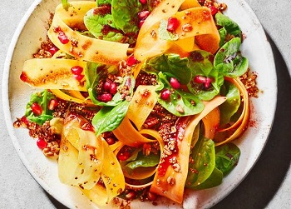
Carrot ribbon salad with quinoa granola (V)
Serves 4, Kcals 510, Fiber 11.5g
- 100g quinoa
- 70g rolled oats
- 30g whole almonds, roughly chopped
- 50g pecans, roughly chopped
- 2 tsp cinnamon
- 1 tsp ground ginger
- 2 tbsp coconut oil, melted
- 2 tbsp honey or vegan alternative
- 3 large rainbow carrots, peeled
- 75g baby leaf spinach
- 100g pomegranate seeds
- 2 tbsp fresh mint, roughly chopped, plus extra to serve
- 2 tbsp pomegranate molasses
- 1 tbsp extra virgin olive oil
- 1 tbsp white wine vinegar

- Preheat the oven to 180°C/fan 160°C/gas mark 4. Line a baking tray with greaseproof paper.
- Combine the quinoa, oats, almonds, pecans, cinnamon, ginger, coconut oil and honey. Mix well and spread out on the baking tray. Bake for 15 minutes, then set aside to cool.
- Meanwhile, peel the carrots into long thin ribbons. Put into a large bowl with the spinach, pomegranate seeds and mint.
- Whisk together the molasses, oil and vinegar with seasoning. Once the granola has cooled down completely, sprinkle it into the salad along with the dressing. Toss well to combine. To serve, divide the salad between 4 plates and sprinkle with the fresh mint leaves.

https://www.sainsburys.co.uk/gol-ui/recipes/carrot-ribbon-salad-with-quinoa-granola

