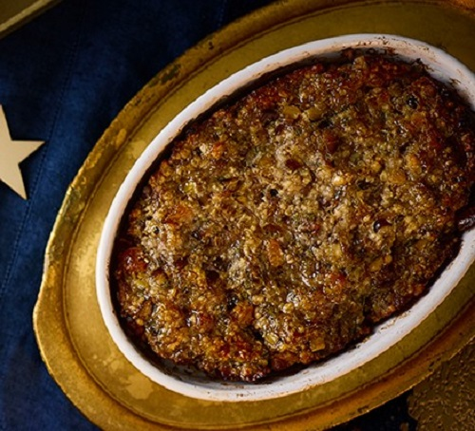
Chestnut & apricot festive stuffing
Serves 6, kcal 615, fibre 9g
- vegetable oil for greasing
- handful of sage finely chopped
- handful of thyme leaves picked
- 500g sausagemeat
- 100g soft white breadcrumbs
- 2 tbsp sherry (or any sweet wine)
- 100g chopped dried apricots
- 150g cooked chestnuts (from a pouch), chopped
- 2 tbsp caramelised red onion chutney
- grating of nutmeg
- pinch of mixed spice

- If your air fryer has a mesh basket or one with holes, use an enamel dish or baking dish that will fit into the air fryer. Oil the dish well. If your air fryer has a flat-sided basket, oil the base and sides.
- Tip all the ingredients into a large bowl and mash well with your hands. Season with salt and lots of pepper. Pack the mixture into the dish or air fryer and smooth out the top.
- Roast at 180C for 25-35 mins (depending on how deep the mixture is) until a metal skewer comes out piping hot when inserted into the middle, or when a cook’s thermometer reaches 70C, and the top is golden. Cover with foil for the last 15 mins if the top is browning too much.

