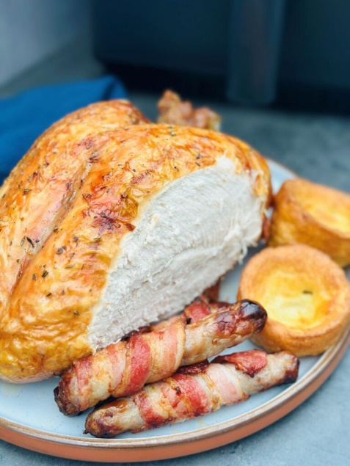
Air fryer turkey crown
Serves 6, kcal 424, fibre 2g
Cook this turkey crown in an air fryer to free up oven space and speed up the cooking process. Before cooking, be sure to check that your air fryer will fit the whole crown
- 1.7kg turkey crown
- 1 tsp vegetable oil
- 1 tsp dried mixed herbs
- 1 clementine halved
- 1 shallot halved
- 2 garlic cloves bashed
- a few fresh herb sprigs such as sage, thyme or oregano

- Heat the air fryer using the preheat function, or set to 180C for 2 mins. Pat the turkey crown dry using kitchen paper, then rub all over with the oil. Season well, then scatter the dried herbs over the skin.
- If the crown allows, stuff the clementine halves, shallot, garlic cloves and fresh herb sprigs into the cavity. If this is not possible, tuck them around the crown in the air-fryer basket instead. Either way, ensure the turkey crown is skin-side down in the air-fryer basket.
- Cook for 30 mins, then turn the crown over and cook for a further 20-30 mins, or until the juices run clear when pierced with a knife in the thickest part, or a meat thermometer stuck reads 65C. Carve into slices to serve.

